Northern Agricultural Association Inc.
Glencore Singleton Show

22, 23 & 24th September

OPEN DEMOLITION
DERBY

Saturday 23rd September 2017 Commencing after Fireworks
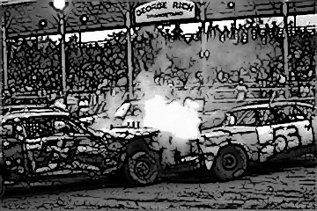
$1500 Purse

Last car running $750
2nd last car running $350
3rd last car running $200
Last running local $200

- 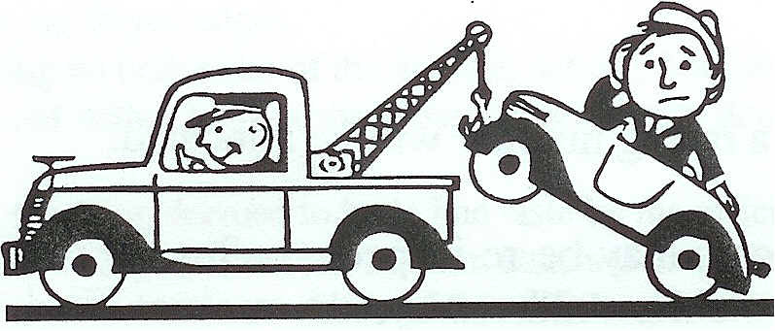

- Car entry fee $50
- Drivers must be 18 and over
- Full list of regulations available from Show Secretary Ph.: 6572 2039
- Entries Close Friday 15th September 2017
- Enquires to Rodney on 0413 456 399
DEMOLITION DERBY RACING RULES
BE ADVISED TO READ THE FOLLOWING RULES CAREFULLY
ALL RULES WILL BE STRICTLY ENFORCED
- Open to all competitors, male and female, over the age of 18 years, with a current driver's license and suitable insurance.
- No consumption of alcohol less than 12 hours before the event. All competitors to be breathalyzed at race briefing.
- The event is started when the GREEN flag is dropped. All action must cease immediately when the RED flag is raised.
- All cars must be at the Showground by 3 pm to be scrutinized between 4.00 pm and 5.00 pm. Any cars not passed will have the opportunity to correct any problems and be re-inspected prior to the race. And any car turning late after scrutineering has finished will not be eligible to enter.
- Crash helmets and belts must be of an approved type and must be worn at all times.
- All drivers must wear racing uniform or overalls. NO THONGS, SHORTS, T - SHIRTS ALLOWED. Overalls and racing uniforms must have full-length sleeves (No bib and brace overalls).
- Any cars immobilized for longer than (1) one minute will be deemed to be out of the event.
- Any cars deemed (by officials) not to be partaking in the demolition of fellow competitors will be automatically disqualified.
- Any driver's door deemed to be hit on purpose by a fellow competitor; the offending driver will be instantly disqualified.
- First and reverse gear to be used only. Any competitor found using second or third gear will be disqualified.
- On receipt of Paid entry, a racing number will be allocated.
- Prize monies. Winning cars may be re-inspected after the event before official placings are given. Placing’s given over the Public Address system are not final until the re-inspections have taken place.
- Decision of Judges, Referee and Scrutinizers' are final.
- The Northern Agricultural Association Inc. reserves the right to refuse the entry of any driver.
DEMOLITION DERBY CAR SPECIFICATIONS
- Cars eligible for entry are any front or rear wheel drive vehicles. No small cars i.e. Barinas/Laser
- No full chassis or v8 vehicles are allowed to compete in the open four &six cylinder demolition derby.
- All exhausts must exit underneath the car. No exhaust is to be put through bonnet, for e.g., drag car style pipes
- Locked differentials are permitted and are optional.
- All external chrome work and protruding objects must be removed (including all cast metals that hold blinker lights etc.
- All glass must be removed NOT broken in.
- All interior linings and handles to be removed.
- All cars are to be cleaned out (no loose objects).
- All doors must be secured by standard chains of no larger than 40mm links and 7mm thickness (no wire) and door lock mechanisms only.
- The driver's door and off side passenger's door (the door behind the driver) are to be stitch welded with 6" (150mm) stitch welds, only the driver's door may be completely welded.
- A 1⁄4” (6mm) metal plate may be slid down the window channel of the driver's door only. The plate is not to protrude past the height of the door skin and may not be welded. External driver’s doorplates that cover the driver’s door are permitted and allowed.
- Bonnets, boot lids, tailgates are to be chained shut. Bonnets AND boot lids MUST be opened for inspection during scrutineering
- No bolting, welding or strengthening of any bonnet, boot lid, mudguard, bumper bar or seam.
- Mudguards and wheel arches are not to be cut away or bent.
- No Tow Bar assemblies are permitted and must be completely removed.
- No Engine Modifications allowed.
- Engine and gearbox mounts may be solid or a similar shape. If cutting a hole in a floor shift it is not to be any larger than 8" x 8" (200mm x 200mm).
- Battery may be relocated to the passenger's front floor, covered with RUBBER MATTING and be securely fastened to the floor with metal strips or a battery cradle.
- CARS ARE TO USE ONE 13 PLATE CAR BATTERY - NO TRUCK BATTERIES ALLOWED.
- Radiators must be of original type and in original position.
- Fans blades may be removed.
- No additional heater tanks, radiators, top-up bottles or hoses.
- ABSOLUTELY NO MODIFICATIONS TO THE COOLING SYSTEM ARE ALLOWED - apart from fan blades may be removed.
- All airbags must be completely removed
- Fuel tanks - original fuel tanks are not to be used. Alternative tank must be steel "jerry can", and be secured to the middle of the rear firewall in a safety cradle.
- No plastic bottles permitted.
- The original fuel line must be used from the engine bay to the entrance of the "jerry can" where approved one (2) meter (maximum length) flexible fuel hose may be used.
- Driver's seat must be reinforced either by rope strapping or preferably chain between the center pillars and behind the seat. (See diagram E)
- One bar from pillar to pillar (center pillars) may be used. Bar must be at least 140mm. Plates not less than 100mm x 100mm are to be welded on each end and bolted to pillars (not welded) by at least two (2) bolts each side through pillars and plates. Bolts must be no less than 6mm thick and bolted from outside inwards.
- Approved seat belts must be fitted to the vehicle, i.e. lap sash or four point harnesses.
- No other types of seat belts are acceptable - NO RETRACTABLE SEAT BELTS ALLOWED.
- Belts must be in good condition, i.e.: no frayed edges.
- Car numbers must be in large lettering on both sides of the vehicle. Ideally both rear doors.
- The driver's door must be painted red with a large white cross. Any driver's door not painted with the specific color’s will be fined $10.
- All sign writing will be inspected. Anything deemed to be in bad taste by the officials must be removed.
- All vehicles must be fitted with a white flag of 300mm x 300mm attached to a piece of 1⁄4” (6mm) wooden dowel (no bigger) so that the flag is no lower than 300mm above the roof line of the vehicle.
- The dowel is to be attached, with tape, to the right hand pillar within reach of the driver.
- The driver is to break the flag off as soon as his vehicle is immobilized, indicating that the vehicle is no longer in the event and no longer a target.
- Any foam cushioning must be fully covered. No rope to be used in car apart from driver's seat strapping (diagram E) Brakes - All brakes, both front and rear must be in original working order.
- ABSOLUTELY NO MODIFICATIONS TO THE BRAKE SYSTEM ARE PERMITTED.
- ORIGINAL FUEL TANKS ARE TO BE THOROUGHLY RINSED WITH WATER AND ARE TO HAVE A HOLE PUNCHED IN THE BOTTOM.

Gate Entry
Adult - $15.00
Aged Pensioner - $5.00
Child 13 to 18 years - $10.00
Child 5 to 12 years - $5.00
Children under 5 years FREE
For further information on 2017 Singleton Show and hiring of Showground Facilities Please contact
The Secretary
Northern Agricultural Association Inc.
PO Box 124 Singleton 2330
Phone 02 6572 2039 Fax 02 6572 2393
Email secretary@singletonshow.com
Website www.singletonshow.com

